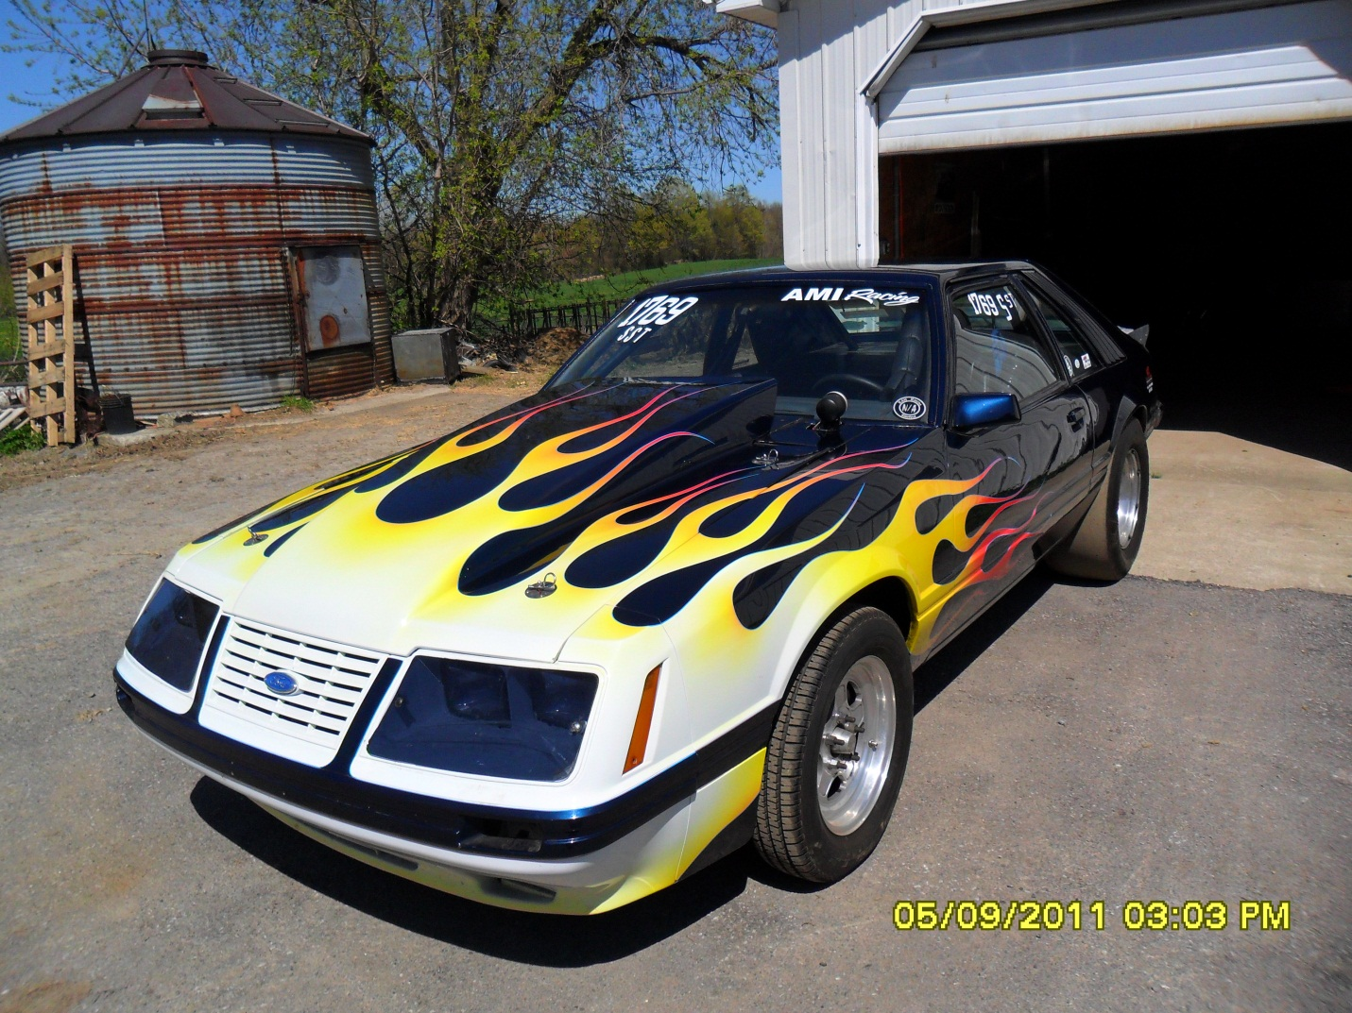
1985 MUSTANG HATCH ROLLING CHASSIE
Body in Very Good Condition, no rot, Custom Paint

Tube Front K-Member with Coil overs, Caster Camber Plates, Disc Brakes
Ladder Bar Rear Suspension, 8.8 Housing with Big Bearing Ends, Welded with Extra Bracing also1
Disc Brakes, Spool with 4:56 Gears, 33 Spline
10 Pt that was certified
Bogart Rims, 28x10.5 Micky Thompson
Digital 7 Ignition Box
Interior Finished with Black Aluminum Door Panels as well in Back Seat Aera
Motor Plates for Small Block Ford ASKING $5500.00 CALL 716 863 2605

